

Name: Soham Santosh Salunkhe
PRN: 12520054
College: Vishwakarma Institute of Technology, Pune
Branch: Computer Science and Engineering (CSCBI)
Roll No.: 15

Practical No. 3

Title:- Network Connecting Devices: Bridge, Gateway, Modem, Wireless infrastructure Components

- Introduction to Network Connecting Devices:-
Network connecting devices are hardware components that help connect multiple computers and other network-enabled devices together to form a network. They allow data to be transmitted, received, and directed efficiently within the network or between different networks. These devices play a vital role in data communication, network management, performance optimization, and security. Common network devices include Hub, Switch, Router, Repeater, Bridge, Gateway, Modem, and Wireless Infrastructure Components. Each device has a specific function in building and maintaining network connectivity.

- Bridge:-
Functioning:
- A bridge works at the Data Link Layer (Layer 2).
- It is used to connect and filter traffic between two LAN segments, making them function as a single network.
- Bridges use MAC addresses to decide whether to forward or filter frames.
- Helps reduce collisions and manage traffic.
Applications:
- Useful for dividing a large LAN into smaller segments for better performance.
- Used in legacy networks to connect different network segments.

Simulation:-
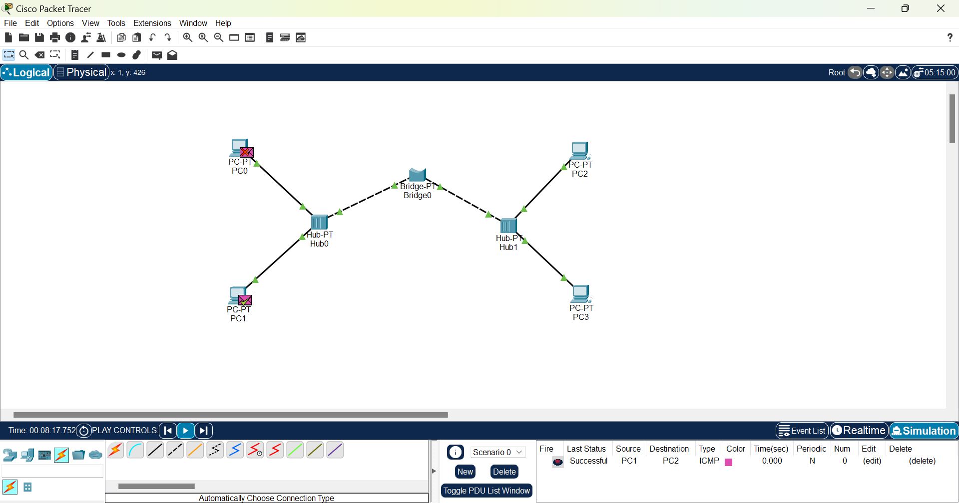

- Gateway:-
Functioning:
- A gateway operates at multiple layers of the OSI model.
- It acts as a translator between two different network protocols, architectures, or data formats.
- Unlike routers, gateways can convert data formats to enable communication between dissimilar networks.
Applications:
- Used to connect different types of networks, such as LAN to a mainframe or Internet to an industrial control system.
- Common in enterprise systems, cloud services, and protocol conversions.

- Modem:-
Functioning:
- A modem (Modulator–Demodulator) converts digital signals to analog for transmission over telephone lines and analog to digital for receiving.
- It enables computers to communicate over traditional telephone networks or DSL lines.
Applications:
- Used in homes and offices to connect to the Internet through ISP.
- Common in broadband connections like DSL or cable Internet.

Simulation:
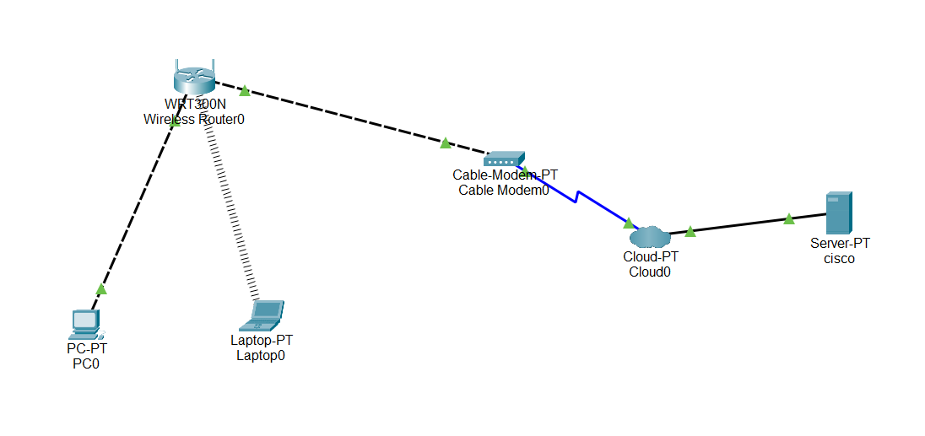
- Wireless Infrastructure Components:-
Functioning:
- These include devices like Wireless Access Points (WAPs), Wireless Controllers, and Wireless Bridges.
- They enable devices to connect wirelessly to a network using Wi-Fi standards (IEEE 802.11).
- Access Points act as central transmitters and receivers, allowing multiple wireless devices to communicate with the wired network.
Applications:
- Widely used in homes, offices, campuses, and public places.
- Enable mobility, easy network expansion, and reduced cabling.
- Ideal for providing wireless Internet access to laptops, mobiles, and IoT devices.

Circuit :
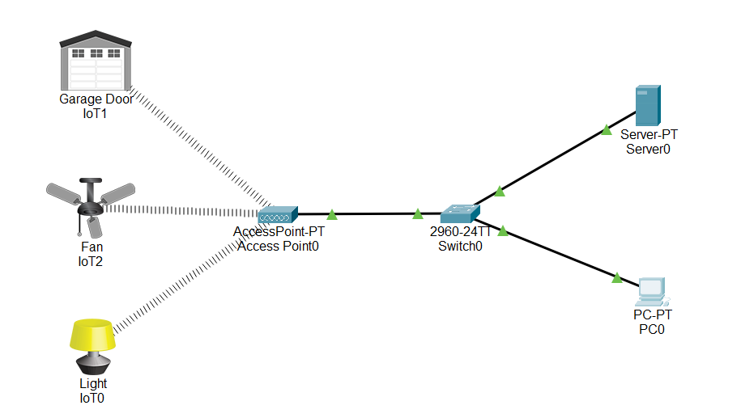
Simulation:
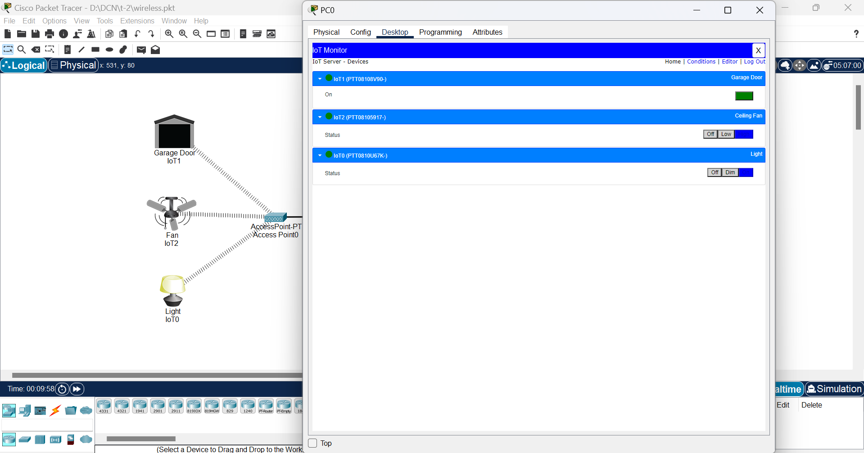

Conclusion :-
Hence, we have studied Bridge, Gateway, Modem, and Wireless Infrastructure Components, each vital for communication. The bridge connects networks, the gateway links different protocols, the modem provides internet access, and wireless components enable cable-free connectivity, ensuring smooth and efficient network communication.

